TIC-TAC-TOE (DOCUMENTATION)

|  |
| --- |
| Title: TIC-TAC-TOE |

|  |  |
| --- | --- |
| ROLL No | NAME |
| 2251-10-737-086 S.shravya | |

|  |
| --- |
| GUIDE: Ms Usha Sri G |

|  |
| --- |
| Project Duration: 14 July 2011 to 03 Nov 2011 |

B.E 2/4 IT 1Semester

Department of Information Technology

M.V.S.R Engineering College

**Students’ Request for Guide**

We, the students of 2/4 1 Sem. IT here by request you to guide our Mini Project,

“ TIC-TAC-TOE “.

S.No Names Roll Nos

1. K.Siddhartha 2451-10-737-081

1. K.Mounica 2451-10-737-080

1. S.Shravya 2451-10-737-086

**Guide’s Consent**

I , Mr./Ms/Dr. G Usha Sri , here by give my consent to guide the Mini Project

“ TIC-TAC-TOE “ ,

with a batch of students that made a request above.

Date: 28-7-2011

Name:G Usha Sri

Designation: Asst Professor

Department of Information Technology

# **Title : TIC-TAC-TOE**

**Statement of Problem:**

Games like su-do-ku,tic-tac-toe and chess increases the ability of thinking in every individual. Peole getting bored with their daily work try to refresh themselves by playing (onw of the means of refreshment). But there may be situations when a person is alone and cannot acess games like these. So, there is a need for artificial intelligence in the absence of others. Hence there is a need to develop games like these in pc.

**Scope of work:**

1. Creation of single player and two player game.
2. taking the inputs and checking the conditions for result.
3. developing artificial intelligence
4. linking all the functions
5. performing all the operations in c++

**Guide’s Signature**

content

1. [NAME](http://206.192.68.20/code/perl/TicTacToe/TicTacToe.html#name)
2. SYSTEM REQUIREMENTS
3. HOW TO OPEN THE GAME
4. SOURCE CODE
5. DISCRIPTION
6. [SAMPLE OUTPUT](http://206.192.68.20/code/perl/TicTacToe/TicTacToe.html#sample_output)
7. [REFERENCES](http://206.192.68.20/code/perl/TicTacToe/TicTacToe.html#see_also)
8. [AUTHOR, COPYRIGHT, LICENSE](http://206.192.68.20/code/perl/TicTacToe/TicTacToe.html#author__copyright__license)

**NAME**

**TicTacToe.pl** - a text version of a simple one player and two player game in c++.

**SYSTEM REQUIREMENTS**

1-OS (windows xp/ windows vista/ windows 7/mac)

2-Compilers (turbo c/DevC++)

3-DevC++ preferable than turbo c

**HOW TO OPEN THE GAME**

To go into the game which is based on the output, there are two cases depending on the compiler:

1.***using turbo c:***

Should click on the game icon named tic tac toe for turbo and after opening press 2 things

a.Alt+F9 (for compilation)

b.Ctrl+F9 (for run)

you can play the game on the output screen.

2.***using DevC++:***

Just click on the game icon named tic tac toe for devc++

You can play the game on the output screen.

**SOURCE CODE**

#include<stdio.h>

#include<conio.h>

#include<iostream.h>

#include<stdlib.h>

class tic

{

public:

void playertwo();

void playerone();

};

void tic::playertwo()//2 playes game starts

{

int i,j,k,p=0;

char a[4][4];

for(i=1;i<=4;i++)

{

for(j=1;j<=4;j++)

{

if(i==4||j==4)

{

a[i][j]='e';

}

else

{

a[i][j]='*';

}

}

}

cout<<"enter the co-ordinates as per the given sequence\n\n";

cout<<"\t";

for(i=1;i<=3;i++)

{

for(j=1;j<=3;j++)

{

cout<<a[i][j]<<"("<<i<<","<<j<<")";

cout<<" ";

}

cout<<"\n\n\t";

}

for(k=1;k<=5;k++)

{

cout<<"\nplayer-1 enter x and y co ordinates\n";

cin>>i>>j;

if(a[i][j]=='*')

{

a[i][j]='x';

}

else

{

cout<<"invalid entry,please re enter it";

cout<<"\nplayer-1 enter x and y co ordinates\n";

cin>>i>>j;

if(a[i][j]=='*')

{

a[i][j]='x';

}

}

cout<<"\t";

for(i=1;i<=3;i++)

{

for(j=1;j<=3;j++)

{

cout<<a[i][j];

cout<<" ";

}

cout<<"\n\n\t";

}

if(a[1][1]=='x'&&a[1][2]=='x'&&a[1][3]=='x'||a[2][1]=='x'&&a[2][2]=='x'&&a[2][3]=='x'||a[3][1]=='x'&&a[3][2]=='x'&&a[3][3]=='x'||a[1][1]=='x'&&a[2][1]=='x'&&a[3][1]=='x'||a[1][2]=='x'&&a[2][2]=='x'&&a[3][2]=='x'||a[1][3]=='x'&&a[2][3]=='x'&&a[3][3]=='x'||a[1][1]=='x'&&a[2][2]=='x'&&a[3][3]=='x'||a[1][3]=='x'&&a[2][2]=='x'&&a[3][1]=='x')

{

cout<<"\t***player 1 wins***\n\n";

break;

}

if(p!=4)

{

cout<<"\nplayer-2 enter x and y co ordinates\n";

cin>>i>>j;

if(a[i][j]=='*')

{

a[i][j]='o';

}

else

{

cout<<"invalid entry,please re enter it";

cout<<"\nplayer-2 enter x and y co ordinates\n";

cin>>i>>j;

if(a[i][j]=='*')

{

a[i][j]='o';

}

}

cout<<"\t";

for(i=1;i<=3;i++)

{

for(j=1;j<=3;j++)

{

cout<<a[i][j];

cout<<" ";

}

cout<<"\n\n\t";

}

cout<<"\n";

if(a[1][1]=='o'&&a[1][2]=='o'&&a[1][3]=='o'||a[2][1]=='o'&&a[2][2]=='o'&&a[2][3]=='o'||a[3][1]=='o'&&a[3][2]=='o'&&a[3][3]=='o'||a[1][1]=='o'&&a[2][1]=='o'&&a[3][1]=='o'||a[1][2]=='o'&&a[2][2]=='o'&&a[3][2]=='o'||a[1][3]=='o'&&a[2][3]=='o'&&a[3][3]=='o'||a[1][1]=='o'&&a[2][2]=='o'&&a[3][3]=='o'||a[1][3]=='o'&&a[2][2]=='o'&&a[3][1]=='o')

{

cout<<"\t***player 2 wins***\n\n";

break;

}

}

else

{

cout<<"\tgame draw\n";

}

p++;

}

}//2playes game ends

void tic::playerone()//1 playes game starts

{

int i,j,k,p=0,t=0;

char a[4][4];

for(i=1;i<=4;i++)

{

for(j=1;j<=4;j++)

{

if(i==4||j==4)

{

a[i][j]='e';

}

else

{

a[i][j]='*';

}

}

}

cout<<"enter the co-ordinates as per the given sequence\n\n";

cout<<"\t";

for(i=1;i<=3;i++)

{

for(j=1;j<=3;j++)

{

cout<<a[i][j]<<"("<<i<<","<<j<<")";

cout<<" ";

}

cout<<"\n\n\t";

}

for(k=1;k<=5;k++)

{

cout<<"\nplayer-1 enter x and y co ordinates\n";

cin>>i>>j;

if(a[i][j]=='*')

{

a[i][j]='x';

}

else

{

cout<<"invalid entry,please re enter it";

cout<<"\nplayer-1 enter x and y co ordinates\n";

cin>>i>>j;

if(a[i][j]=='*')

{

a[i][j]='x';

}

}

cout<<"\t";

for(i=1;i<=3;i++)

{

for(j=1;j<=3;j++)

{

cout<<a[i][j];

cout<<" ";

}

cout<<"\n\n\t";

}

if(a[1][1]=='x'&&a[1][2]=='x'&&a[1][3]=='x'||a[2][1]=='x'&&a[2][2]=='x'&&a[2][3]=='x'||a[3][1]=='x'&&a[3][2]=='x'&&a[3][3]=='x'||a[1][1]=='x'&&a[2][1]=='x'&&a[3][1]=='x'||a[1][2]=='x'&&a[2][2]=='x'&&a[3][2]=='x'||a[1][3]=='x'&&a[2][3]=='x'&&a[3][3]=='x'||a[1][1]=='x'&&a[2][2]=='x'&&a[3][3]=='x'||a[1][3]=='x'&&a[2][2]=='x'&&a[3][1]=='x')

{

cout<<"\t***player 1 wins***\n\n";

break;

}

if(p!=4)

{

t=2;

for(i=1;i<=3;i++)

{

if(a[i][1]=='o'&&a[i][2]=='o')

{

if(a[i][1]!='*'&&a[i][2]!='*'&&a[i][3]!='*')

{

}

else

{

t=0;

a[i][3]='o';

}

}

if(a[i][2]=='o'&&a[i][3]=='o')

{

if(a[i][1]!='*'&&a[i][2]!='*'&&a[i][3]!='*')

{

}

else

{

t=0;

a[i][1]='o';

}

}

if(a[i][1]=='o'&&a[i][3]=='o')

{

if(a[i][1]!='*'&&a[i][2]!='*'&&a[i][3]!='*')

{

}

else

{

t=0;

a[i][2]='o';

}

}

}

if(t!=0)

{

for(j=1;i<=3;i++)

{

if(a[1][j]=='o'&&a[2][j]=='o')

{

if(a[1][j]!='*'&&a[2][j]!='*'&&a[3][j]!='*')

{

}

else

{

t=0;

a[3][j]='o';

}

}

if(a[2][j]=='o'&&a[3][j]=='o')

{

if(a[1][j]!='*'&&a[2][j]!='*'&&a[3][j]!='*')

{

}

else

{

t=0;

a[1][j]='o';

}

}

if(a[1][j]=='o'&&a[3][j]=='o')

{

if(a[1][j]!='*'&&a[2][j]!='*'&&a[3][j]!='*')

{

}

else

{

t=0;

a[2][j]='o';

}

}

}

}

if(t!=0)

{

if(a[1][1]=='o'&&a[2][2]=='o')

{

if(a[1][1]!='*'&&a[2][2]!='*'&&a[3][3]!='*')

{

}

else

{

t=0;

a[3][3]='o';

}

}

if(a[2][2]=='o'&&a[3][3]=='o')

{

if(a[1][1]!='*'&&a[2][2]!='*'&&a[3][3]!='*')

{

}

else

{

t=0;

a[1][1]='o';

}

}

if(a[1][1]=='o'&&a[3][3]=='o')

{

if(a[1][1]!='*'&&a[2][2]!='*'&&a[3][3]!='*')

{

}

else

{

t=0;

a[2][2]='o';

}

}

if(a[1][3]=='o'&&a[2][2]=='o')

{

if(a[1][3]!='*'&&a[2][2]!='*'&&a[3][1]!='*')

{

}

else

{

t=0;

a[3][1]='o';

}

}

if(a[2][2]=='o'&&a[3][1]=='o')

{

if(a[1][3]!='*'&&a[2][2]!='*'&&a[3][1]!='*')

{

}

else

{

t=0;

a[1][3]='o';

}

}

if(a[1][3]=='o'&&a[3][1]=='o')

{

if(a[1][3]!='*'&&a[2][2]!='*'&&a[3][1]!='*')

{

}

else

{

t=0;

a[2][2]='o';

}

}

}

if(t!=0)

{

for(i=1;i<=3;i++)

{

if(a[i][1]=='x'&&a[i][2]=='x')

{

if(a[i][1]!='*'&&a[i][2]!='*'&&a[i][3]!='*')

{

}

else

{

t=0;

a[i][3]='o';

}

}

if(a[i][2]=='x'&&a[i][3]=='x')

{

if(a[i][1]!='*'&&a[i][2]!='*'&&a[i][3]!='*')

{

}

else

{

t=0;

a[i][1]='o';

}

}

if(a[i][1]=='x'&&a[i][3]=='x')

{

if(a[i][1]!='*'&&a[i][2]!='*'&&a[i][3]!='*')

{

}

else

{

t=0;

a[i][2]='o';

}

}

}

}

if(t!=0)

{

for(j=1;j<=3;j++)

{

if(a[1][j]=='x'&&a[2][j]=='x')

{

if(a[1][j]!='*'&&a[2][j]!='*'&&a[3][j]!='*')

{

}

else

{

t=0;

a[3][j]='o';

}

}

if(a[2][j]=='x'&&a[3][j]=='x')

{

if(a[1][j]!='*'&&a[2][j]!='*'&&a[3][j]!='*')

{

}

else

{

t=0;

a[1][j]='o';

}

}

if(a[1][j]=='x'&&a[3][j]=='x')

{

if(a[1][j]!='*'&&a[2][j]!='*'&&a[3][j]!='*')

{

}

else

{

t=0;

a[2][j]='o';

}

}

}

}

if(t!=0)

{

if(a[1][1]=='x'&&a[2][2]=='x')

{

if(a[1][1]!='*'&&a[2][2]!='*'&&a[3][3]!='*')

{

}

else

{

t=0;

a[3][3]='o';

}

}

if(a[2][2]=='x'&&a[3][3]=='x')

{

if(a[1][1]!='*'&&a[2][2]!='*'&&a[3][3]!='*')

{

}

else

{

t=0;

a[1][1]='o';

}

}

if(a[1][1]=='x'&&a[3][3]=='x')

{

if(a[1][1]!='*'&&a[2][2]!='*'&&a[3][3]!='*')

{

}

else

{

t=0;

a[2][2]='o';

}

}

if(a[1][3]=='x'&&a[2][2]=='x')

{

if(a[3][1]!='*'&&a[2][2]!='*'&&a[1][3]!='*')

{

}

else

{

t=0;

a[3][1]='o';

}

}

if(a[2][2]=='x'&&a[3][1]=='x')

{

if(a[3][1]!='*'&&a[2][2]!='*'&&a[1][3]!='*')

{

}

else

{

t=0;

a[1][3]='o';

}

}

if(a[1][3]=='x'&&a[3][1]=='x')

{

if(a[3][1]!='*'&&a[2][2]!='*'&&a[1][3]!='*')

{

}

else

{

t=0;

a[2][2]='o';

}

}

}

if(t!=0)

{

if(a[2][2]=='*')

{

t=1;

a[2][2]='o';

}

else if(a[3][3]=='*')

{

t=1;

a[3][3]='o';

}

else if(a[3][1]=='*')

{

t=1;

a[3][1]='o';

}

else if(a[1][1]=='*')

{

t=1;

a[1][1]='o';

}

else if(a[1][3]=='*')

{

t=1;

a[1][3]='o';

}

else if(a[1][2]=='*')

{

t=1;

a[1][2]='o';

}

else if(a[2][1]=='*')

{

t=1;

a[2][1]='o';

}

else if(a[2][3]=='*')

{

t=1;

a[2][3]='o';

}

else if(a[3][2]=='*')

{

t=1;

a[3][2]='o';

}

}

cout<<"\nafter computer entry\n\n";

cout<<"\t";

for(i=1;i<=3;i++)

{

for(j=1;j<=3;j++)

{

cout<<a[i][j];

cout<<" ";

}

cout<<"\n\n\t";

}

cout<<"\n";

if(a[1][1]=='o'&&a[1][2]=='o'&&a[1][3]=='o'||a[2][1]=='o'&&a[2][2]=='o'&&a[2][3]=='o'||a[3][1]=='o'&&a[3][2]=='o'&&a[3][3]=='o'||a[1][1]=='o'&&a[2][1]=='o'&&a[3][1]=='o'||a[1][2]=='o'&&a[2][2]=='o'&&a[3][2]=='o'||a[1][3]=='o'&&a[2][3]=='o'&&a[3][3]=='o'||a[1][1]=='o'&&a[2][2]=='o'&&a[3][3]=='o'||a[1][3]=='o'&&a[2][2]=='o'&&a[3][1]=='o')

{

cout<<"\t***computer wins***\n\n";

break;

}

}

else

{

cout<<"game draw\n";

}

p++;

}//for loop

}//1playes game ends

main()

{

int ch,q=1;

tic k;

while(1)

{

if(q==1)

{

cout<<"select your choice: 1-player vs com\n\t 2-player vs player\n\t 3-exit\n";

cin>>ch;

q++;

}

else

{

cout<<"\n\nwant to play another game??\nselect your choice: 1-player vs com\n\t 2-player vs player\n\t 3-exit\n";

cin>>ch;

}

switch(ch)

{

case 1:k.playerone();

break;

case 2:k.playertwo();

break;

case 3:exit(0);

}

}

}

**DESCRIPTION**

The program plays a game of Tic Tac Toe through a text interface. The moves for the X and O players can be input from the keyboard, including random moves, player selection (1-player game or 2-player game).

While having a computer play a game of Tic Tac Toe does stretch the limits of artificial intelligence according to the logic developed, this code does at least give an example the pieces that go into a program that is more than a trivial exercise.

We have tried to keep the entire code in one file straightforward (i.e. no objects, all the code in one file, no external packages), so that this example won't be too extreme for my intro programming students. Whether I've succeeded in this attempt in making all as a whole; the whole thing has grown upto 570 lines.

The [SAMPLE OUTPUT](http://206.192.68.20/code/perl/TicTacToe/TicTacToe.html#sample_output) section below shows what it all does.

So there you are.

**SAMPLE OUTPUT**

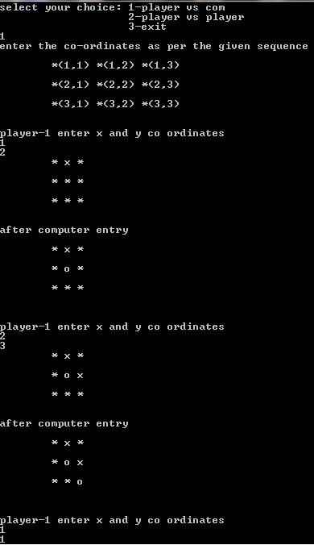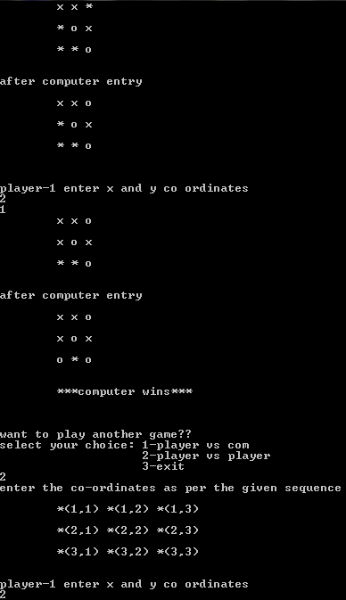

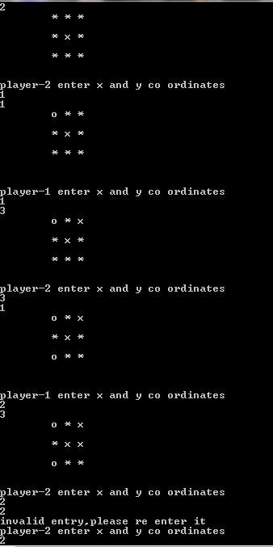

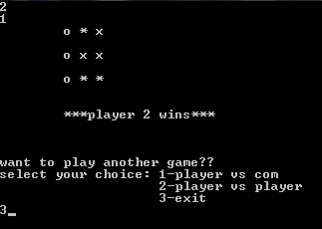

**REFERENCE**

1) Let us C by Yashwanth Kanethkar.

2) C & DS by P.Radha Ganeshan.

**AUTHOR, COPYRIGHT, LICENSE**

K.SIDDHARTHA

K.MOUNICA

S.SHRAVYA

Copyright 2011,

This is free software; you can redistribute it/or modify it.